# Flutter Application With FireBase Login

Step 1 : Finding Firebase

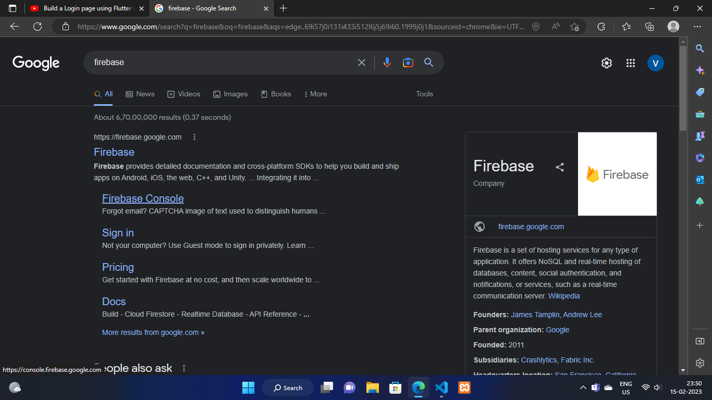

1. Search Firebase on google
2. Go to first link firebase.google.com

Step 2 : Create A Firebase Project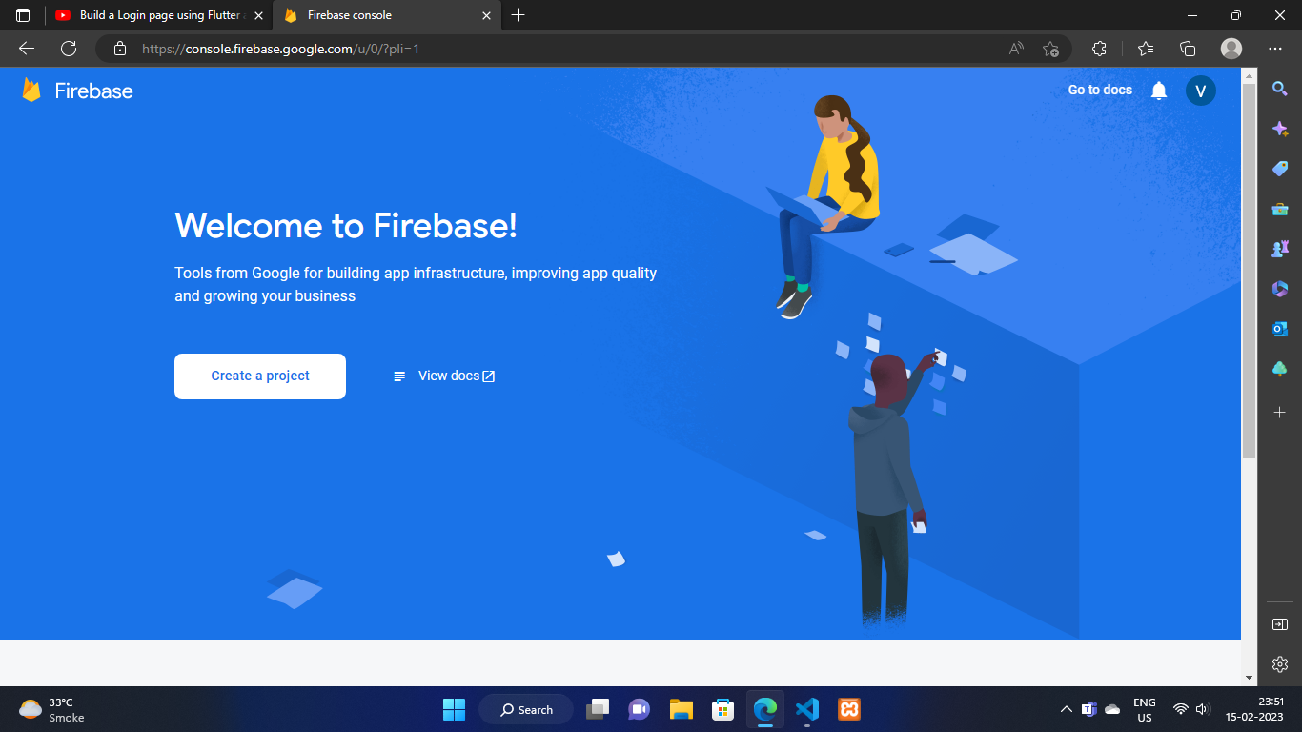

Part 1 :

1. First login with your account
2. Then you’ll be able to see the above page
3. Click on create a project as seen above

Part 2 :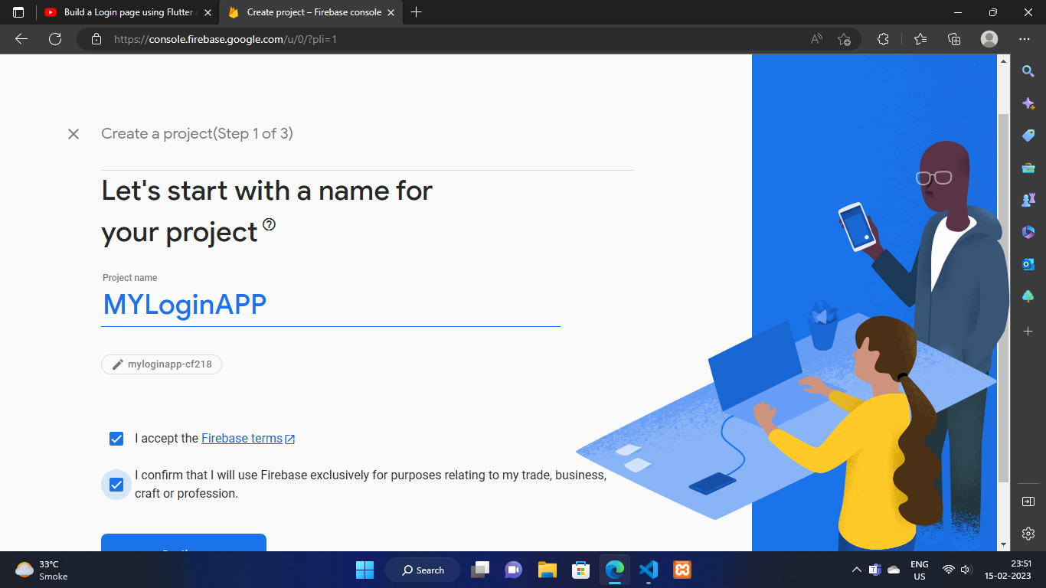

1. Give Any Name To Your Project
2. Fill all the checkboxes
3. Click on continue button

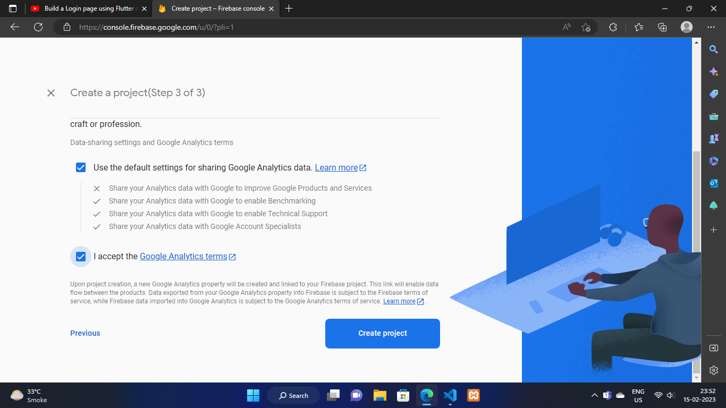

1. Fill the check box as seen above and create project

Part 3:

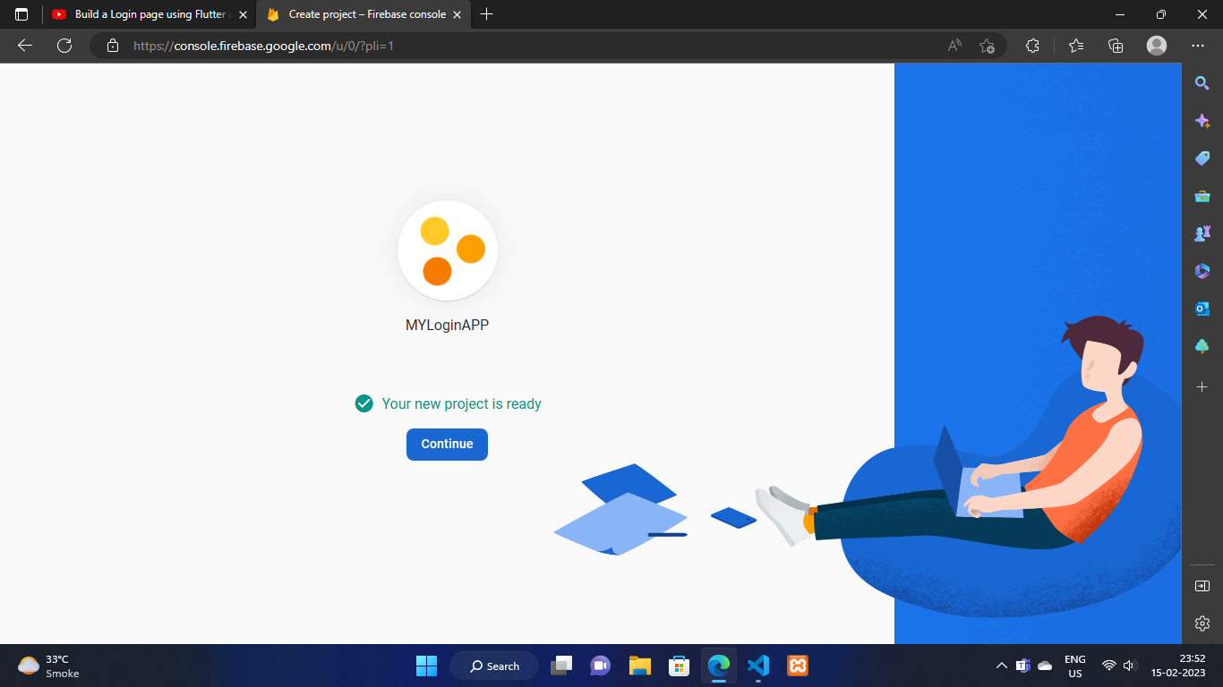

When your project is created you’ll be redirected to this screen , now click on continue button

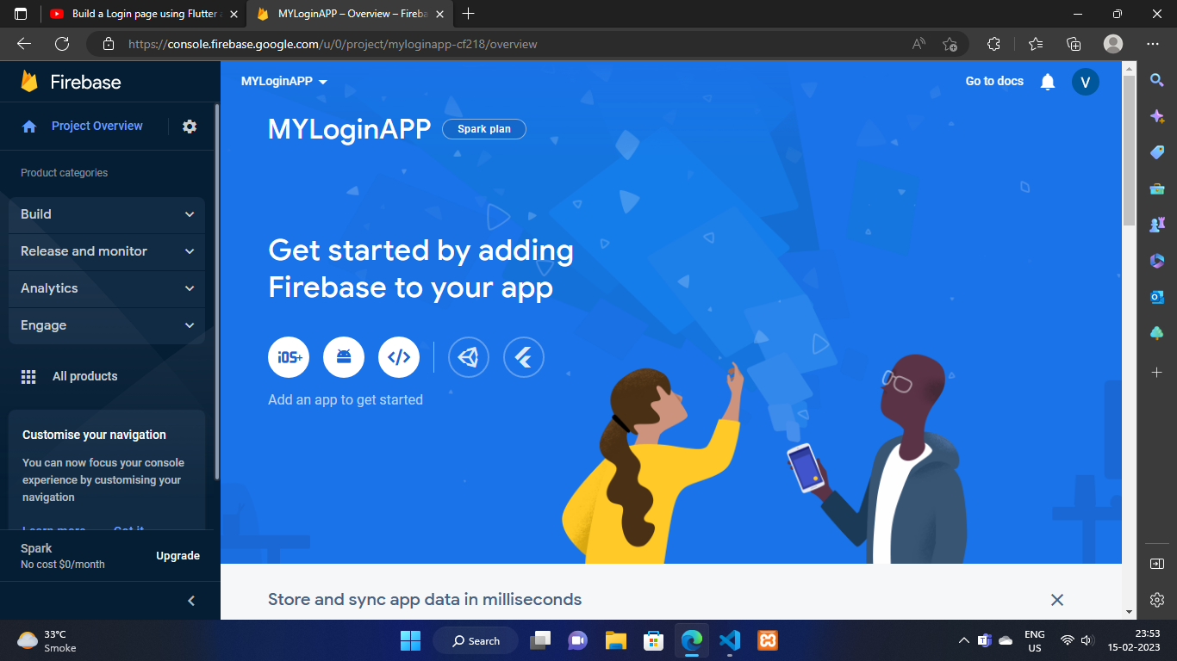

After successful creation of your app you’ll see a dashboard like this

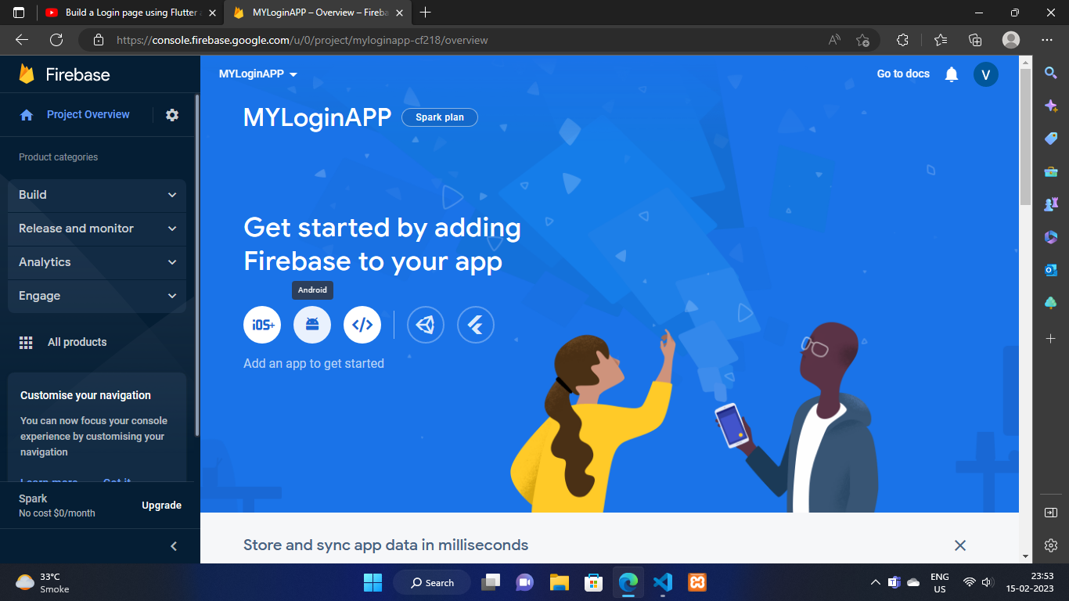

1. Click on android picture as seen above

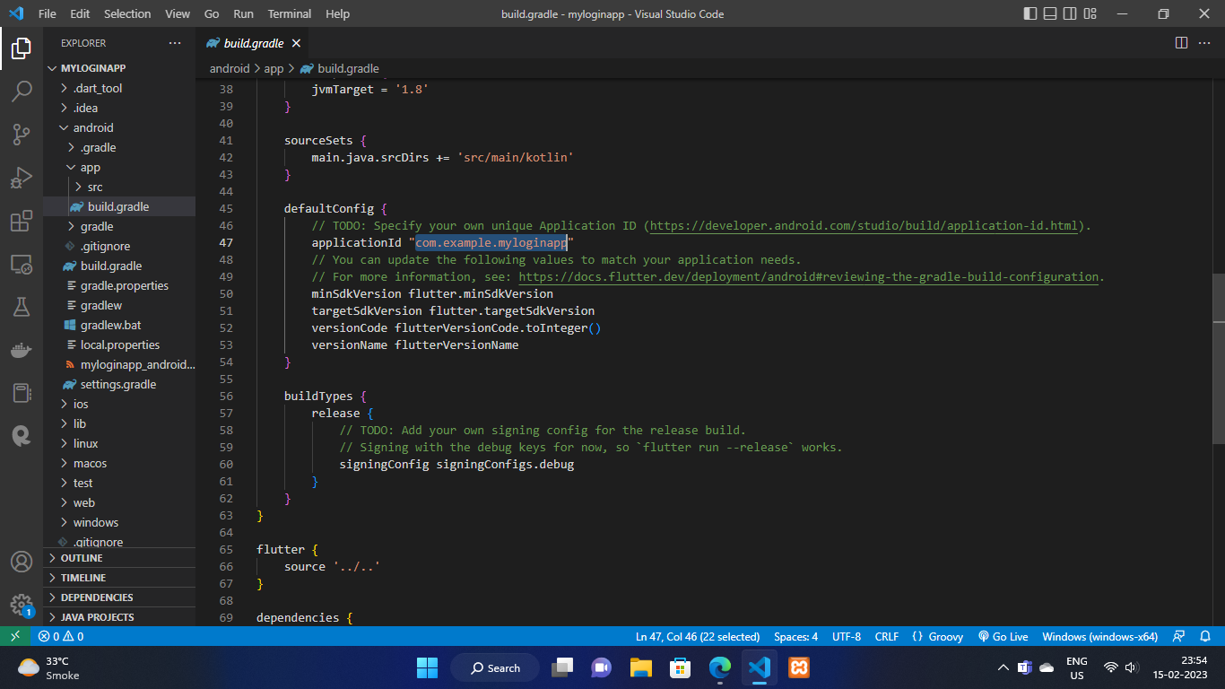

1. Now go to your app in (android->app->build.gradle) and copy the application id of your app

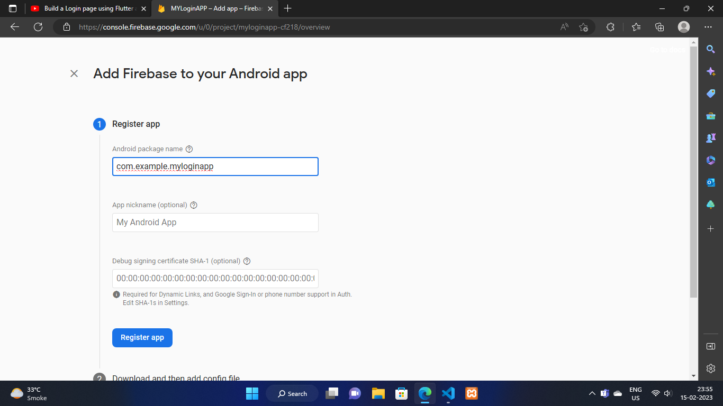

1. Now paste the name to this page

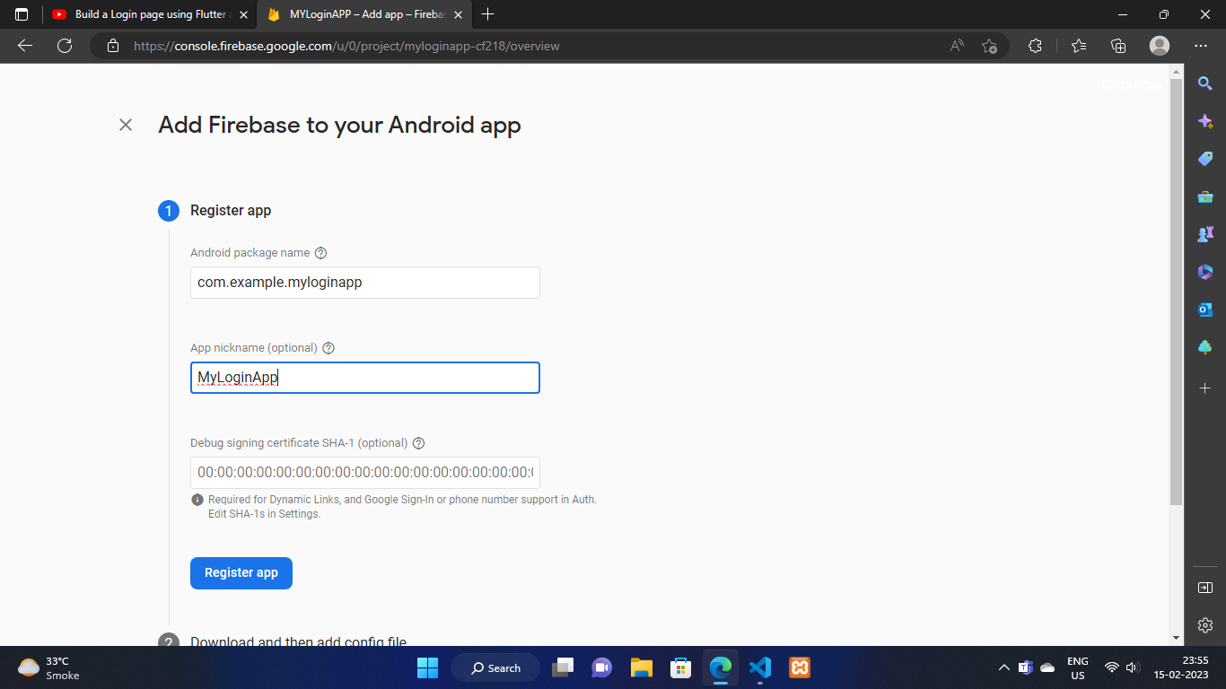

1. Give any random name in this textfield
2. Then click on Register app button

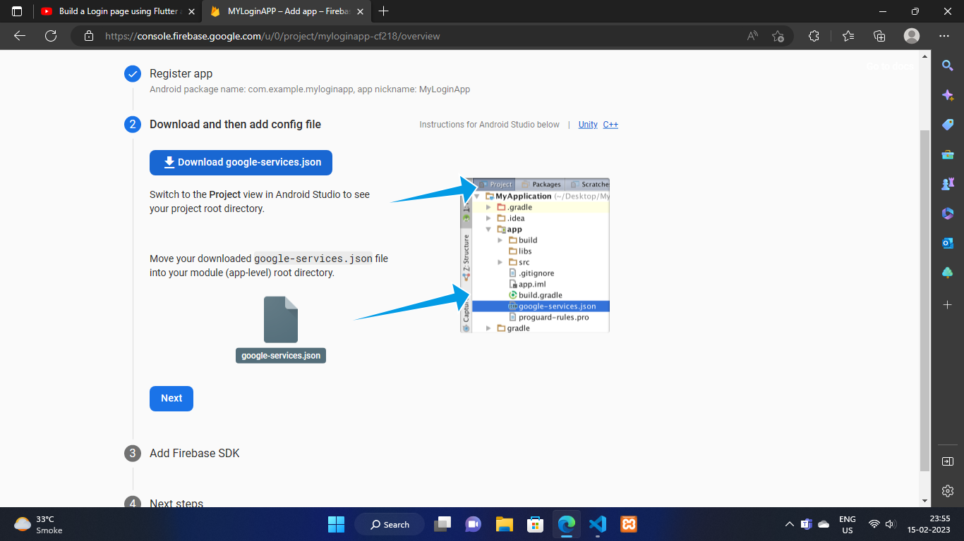

1. Now click on download button a json file will be downloaded

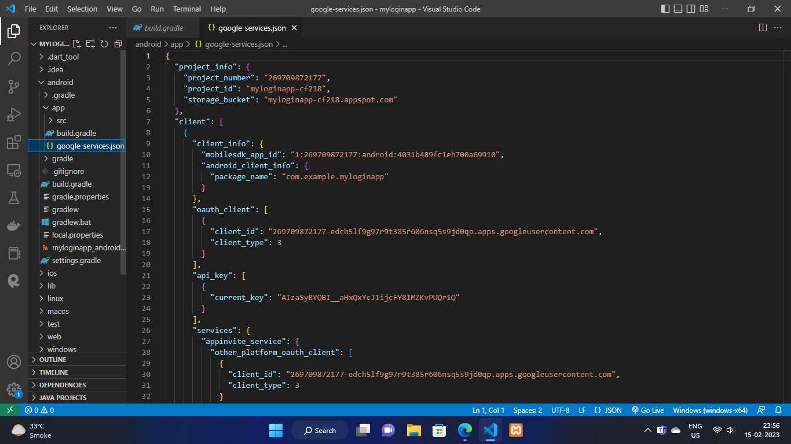

1. Now put the json file inside (android->app) folder
2. Go to firebase console and click on next button of 2nd step

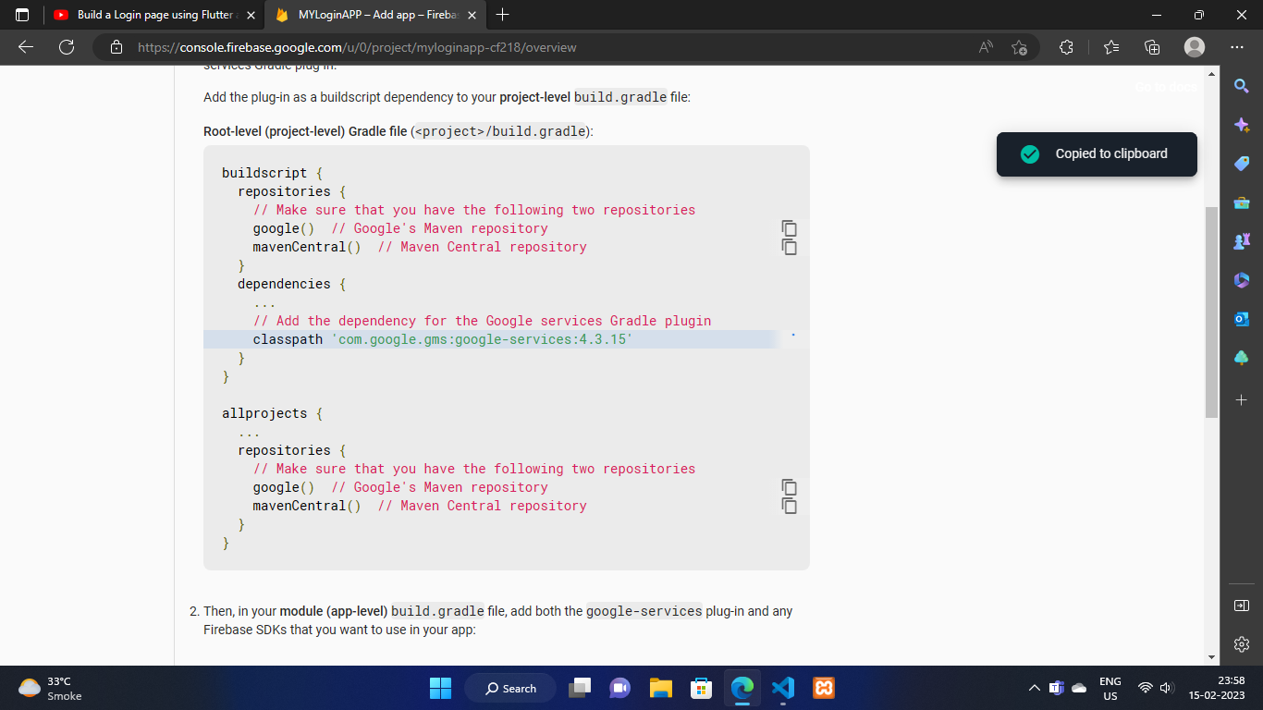

1. Copy the highlighted thing as seen in above image

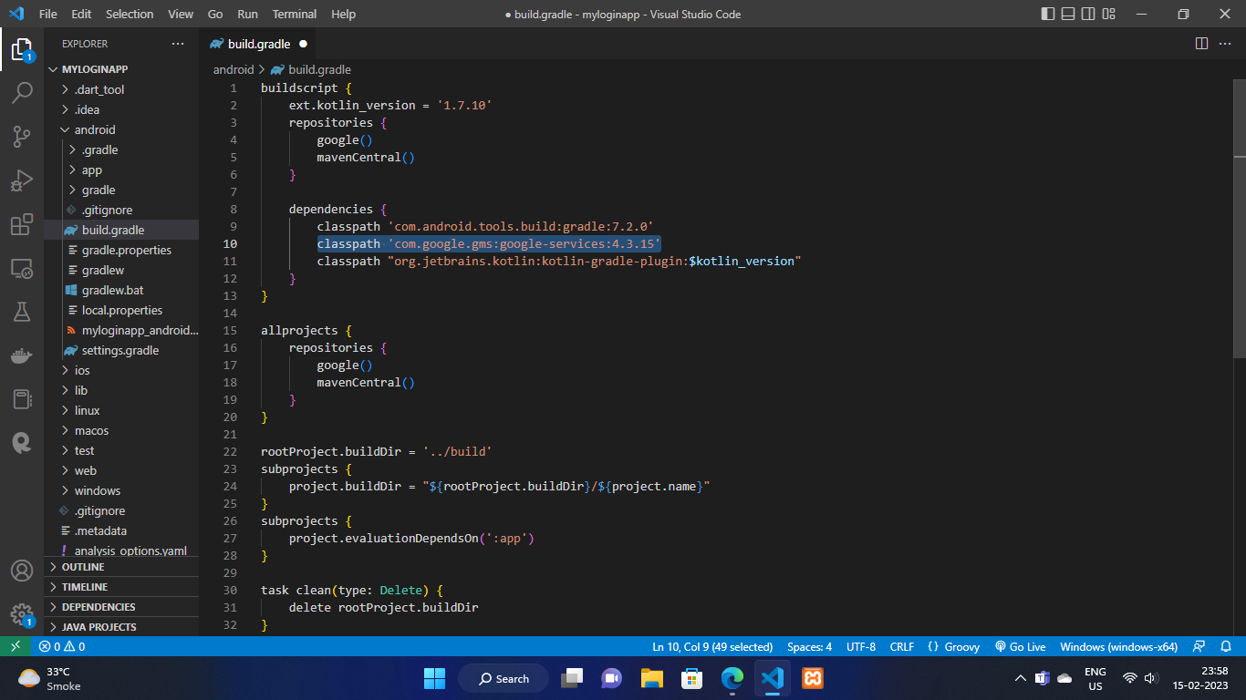

1. Now paste it in android->build.gradle file as seen above

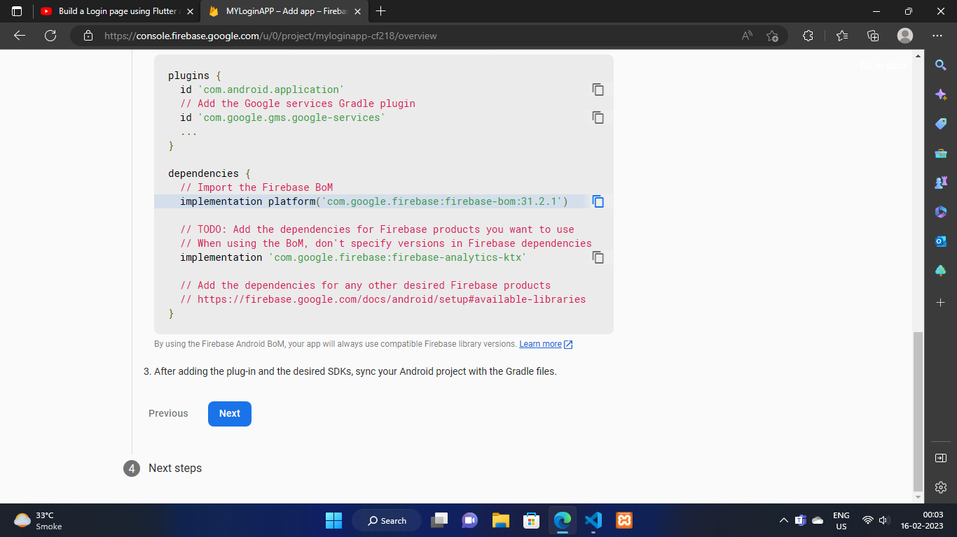

K. Now copy the both implementation thing and paste it in android->app->build.gradle as seen below

L. Now copy both plugins thing and paste it in the same file as mentioned above

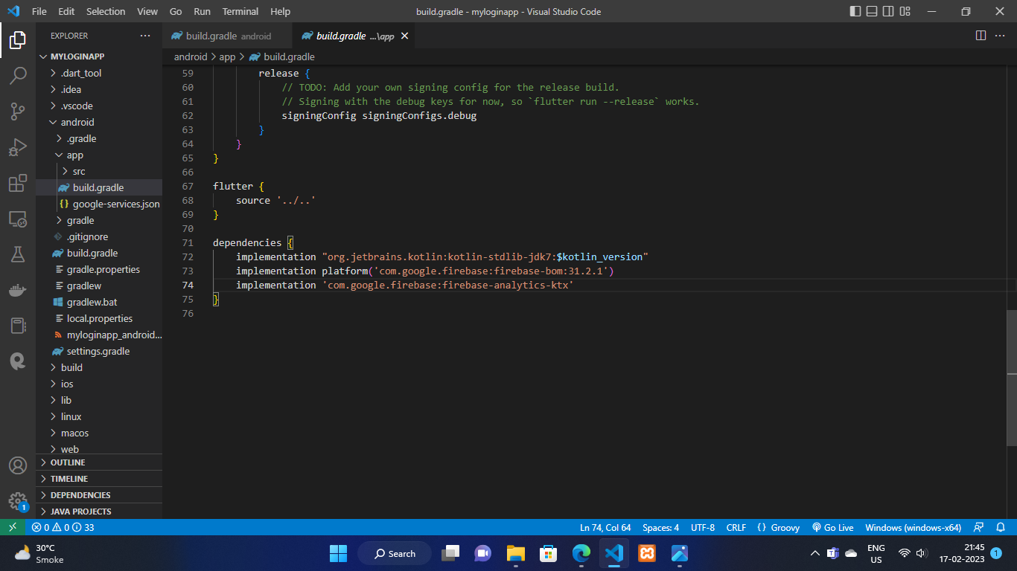

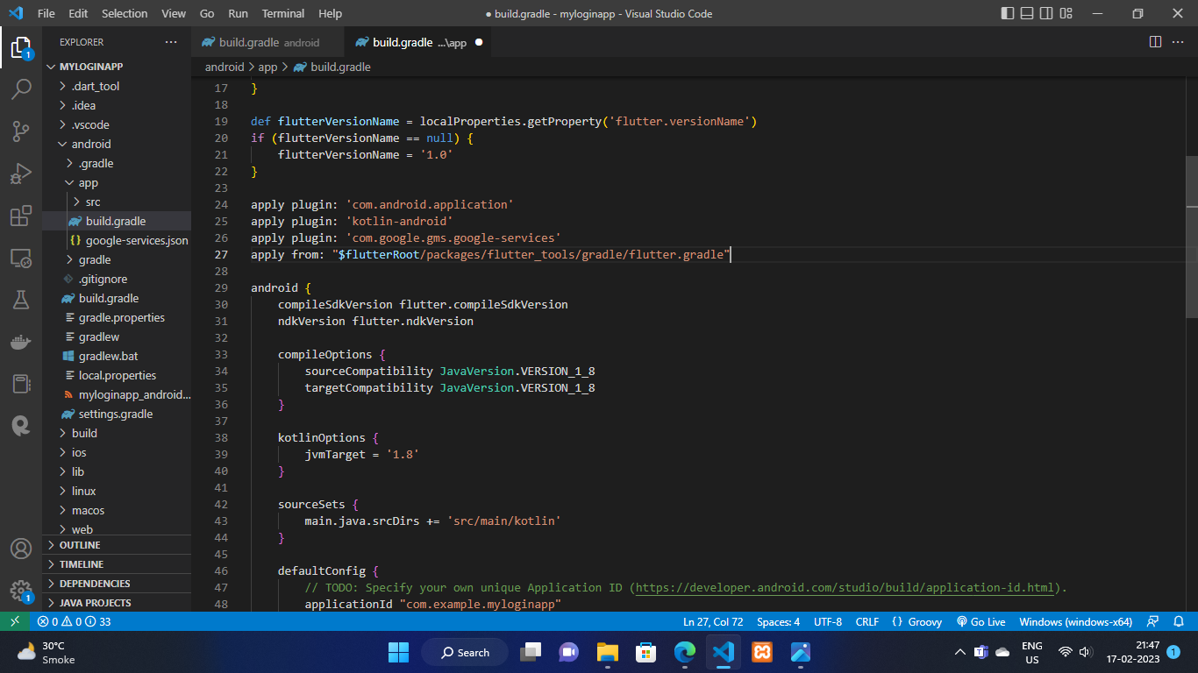

Step 4 :

Part 1 : Adding plugins

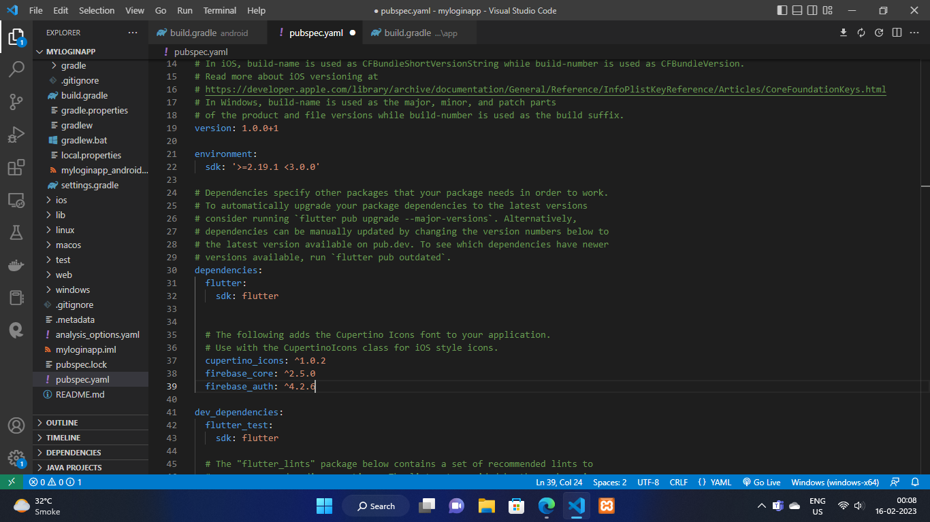

1. Add both the plugin seen above in pubspec.yaml file

Part 2 : Configuring Firebase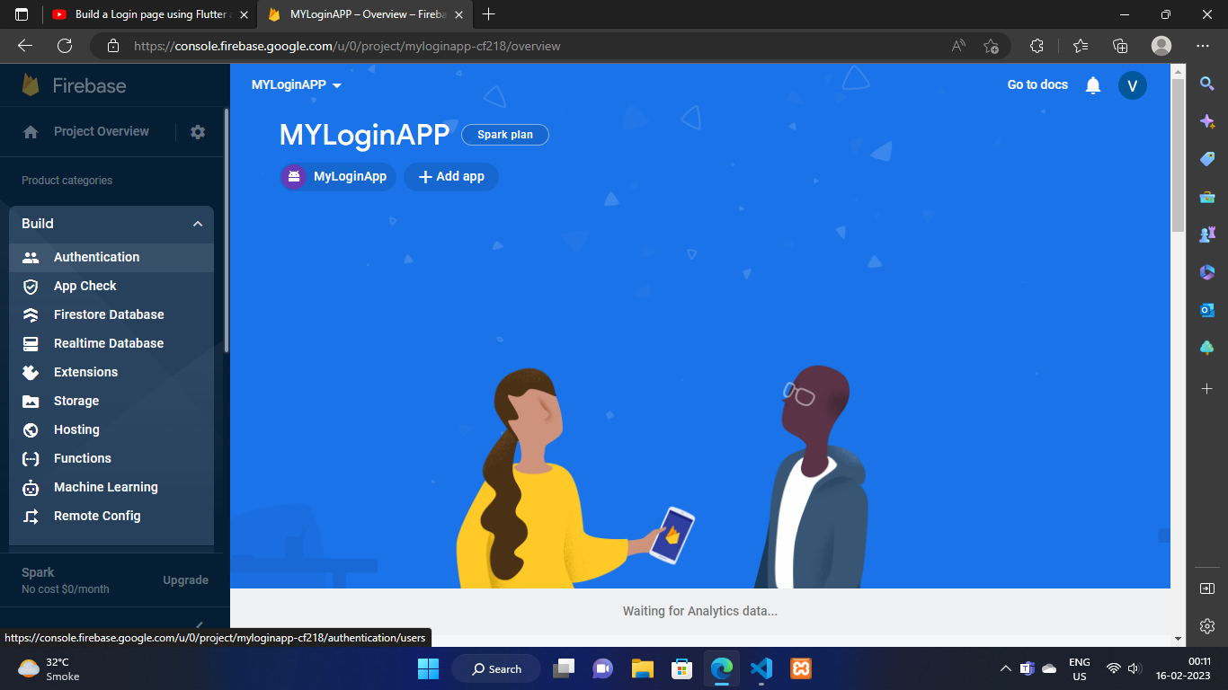

1. Click on the build available in left side bar and then click on authentication as show above

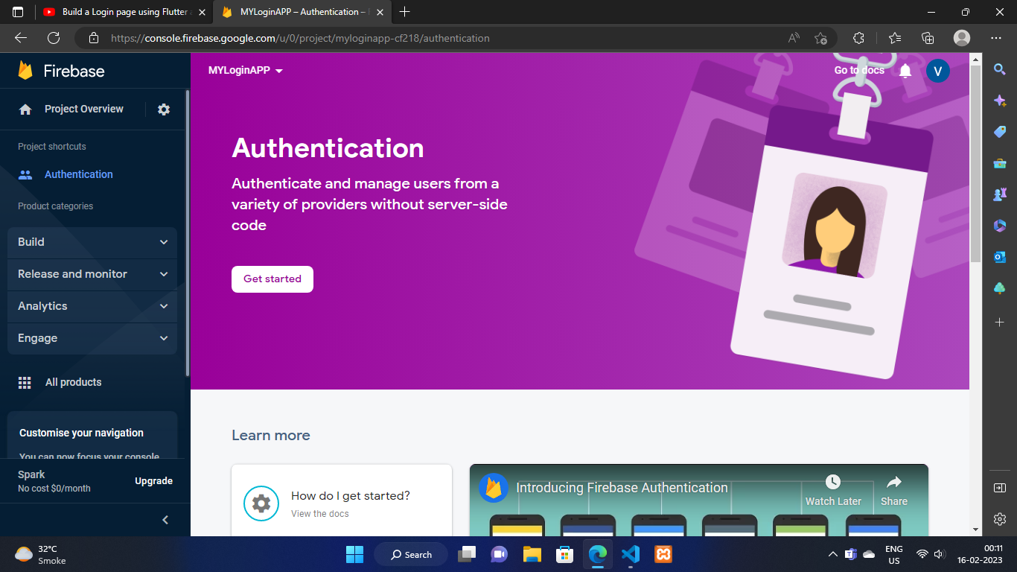

1. Now you should be able to see the page shown above
2. Click on Get Started Button you can see that button

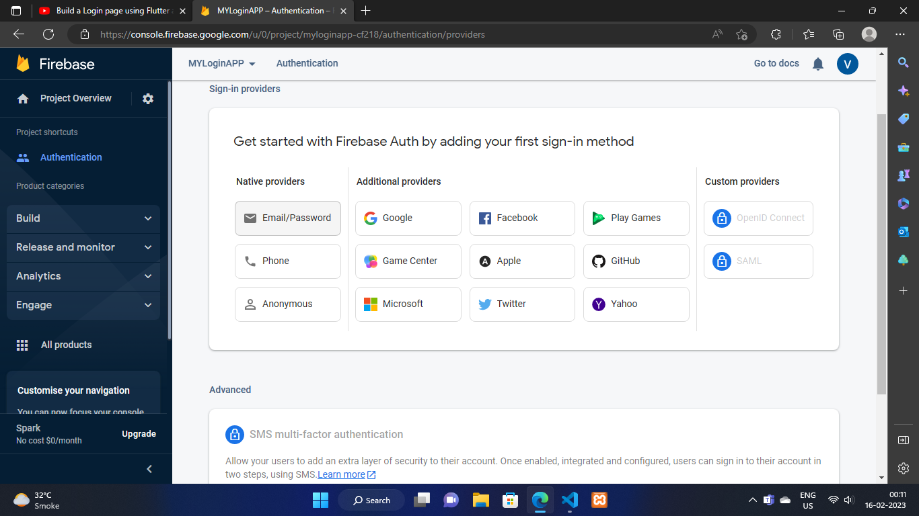

1. Now you will be redirected to this page
2. Now click on the Email/Password button as seen in above image

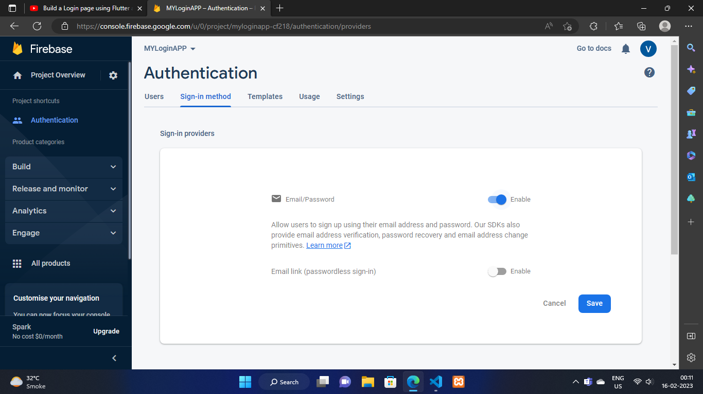

1. Now you will be redirected to this page now just click on the icon to enable it and then click on save button

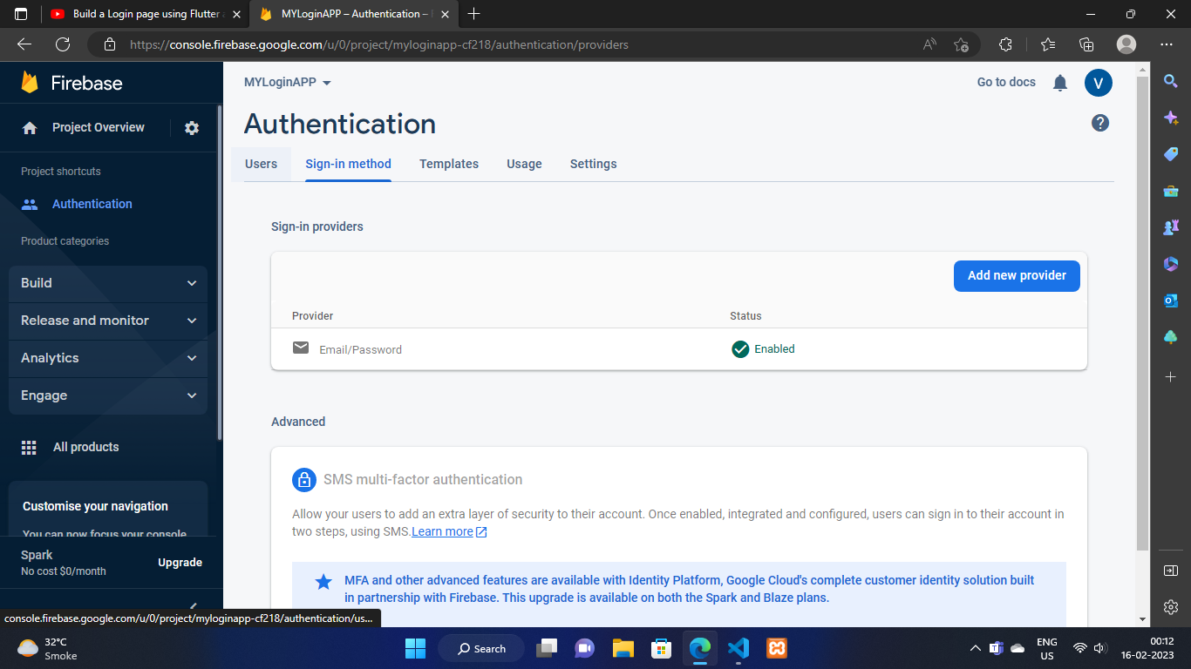

1. If all the processes are successful you’ll be able to see this page
2. Now click on users under Authentication and you will be redirected to page as shown int the below image

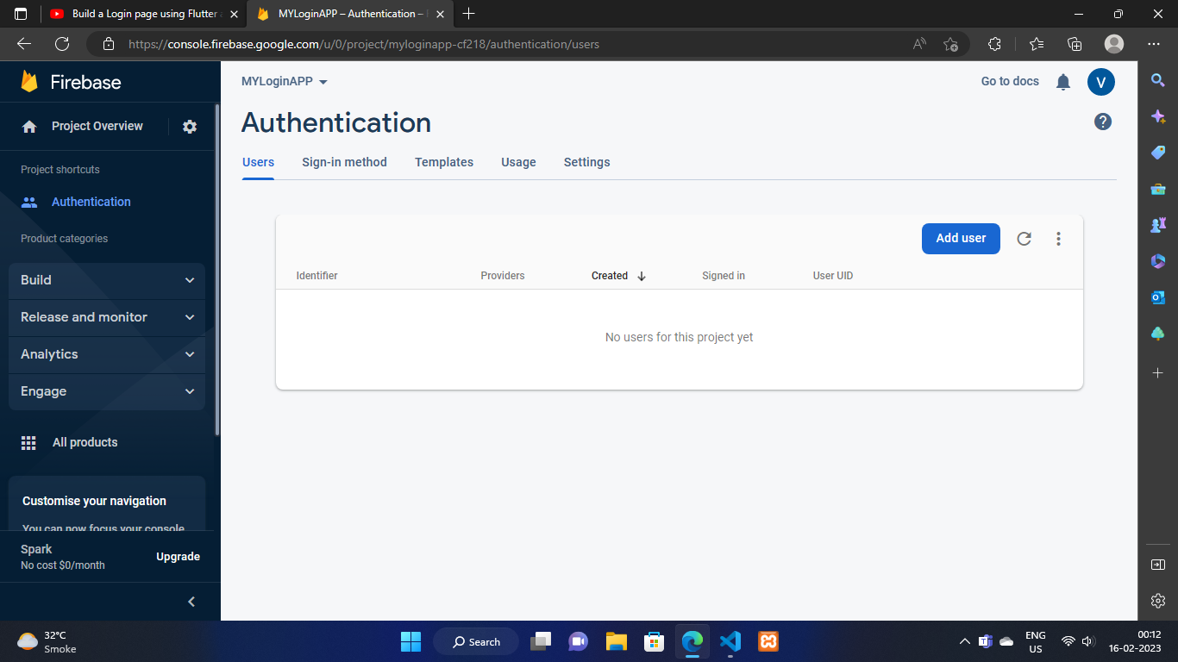

1. Now click on add user button and add a user with email and password (remember the pass as the Firebase doesn't show it afterwards)
2. You should be able to see the the added user as shown in image below

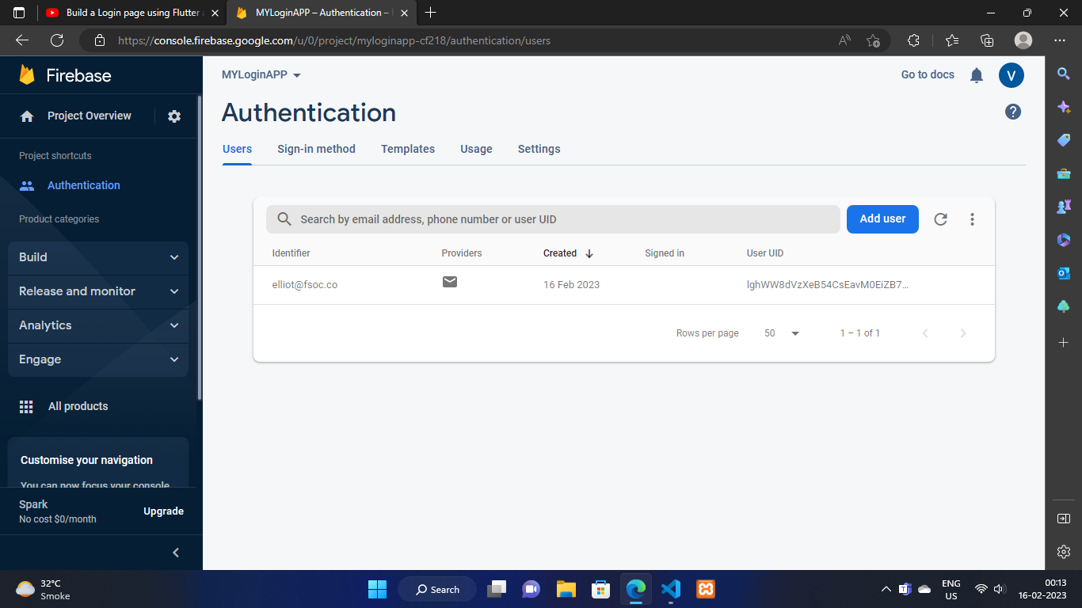

1. Now change the thing shown below

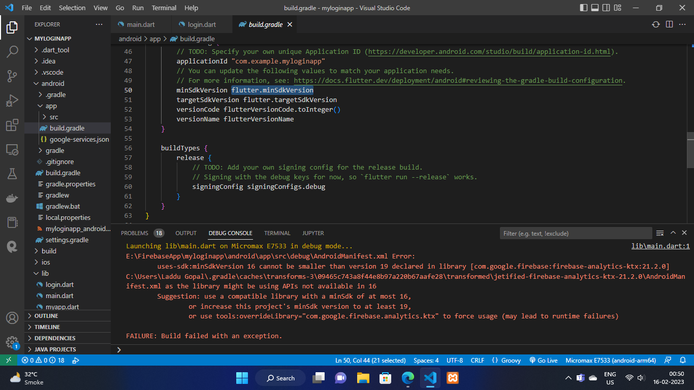 TO—--------------------------------->

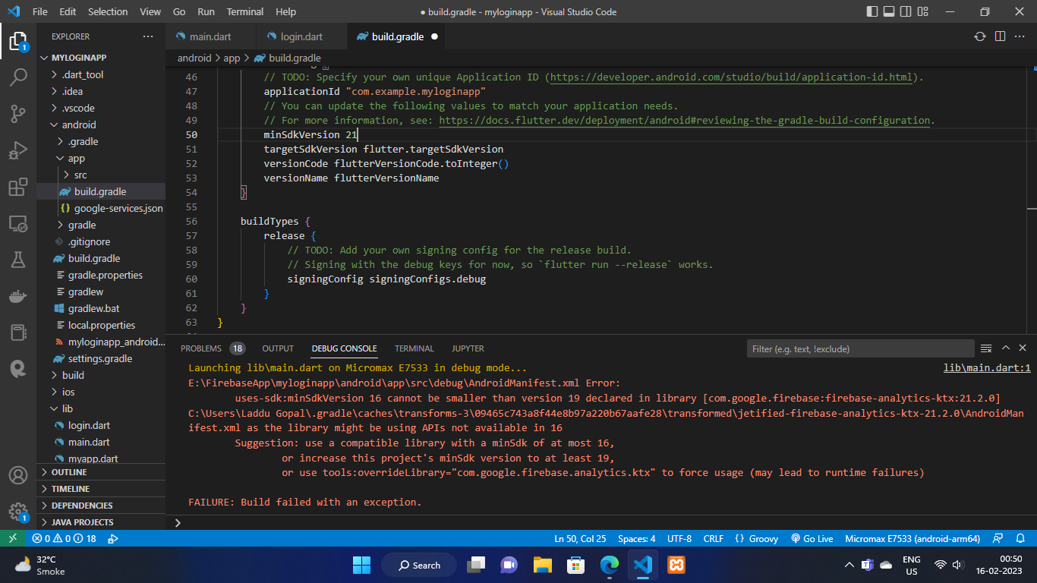

1. Now go to android->app->src->main->Androidmainfest.xml file and add the things shown below in the image

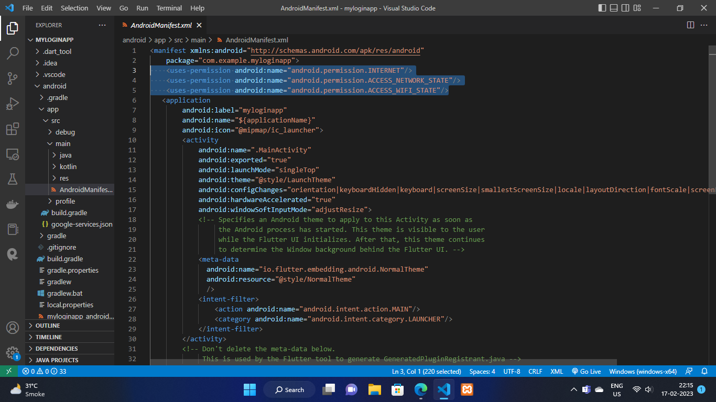

Done With Configs Now

“ Keep Calm And <Code> On “